**Assignment** **-4**

Pyt ho n P rog ra m mi ng

|  |  |
| --- | --- |
| Assig n me nt Date | 25 Octo be r 2022 |
| St ude nt Na me | A.J.John Ebrayeem |
| St ude nt Ro l l N u m be r | 953319104007 |
| Maxi m u m Ma r ks | 2 Ma r ks |

**Question-1:**

Write code a nd co n nectio ns i n wo kwi fo r u lt raso nic se nso r.

W he neve r dista nce is less t ha n 100 c ms se nd "a le rt" to i b m c lo ud a nd dis p lay i n device rece nt eve nts.

U p load doc u me nt wit h wo kwi s ha re li n k a nd i mages of i b m c lo ud

**Solution:**

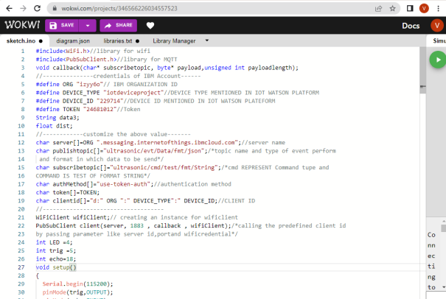

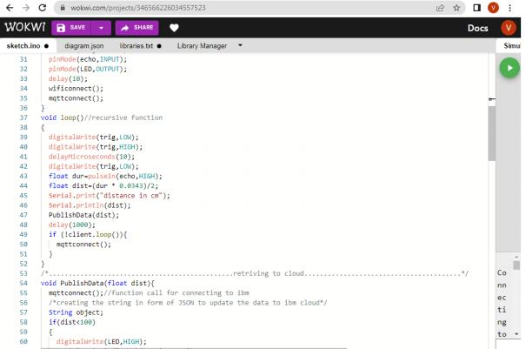

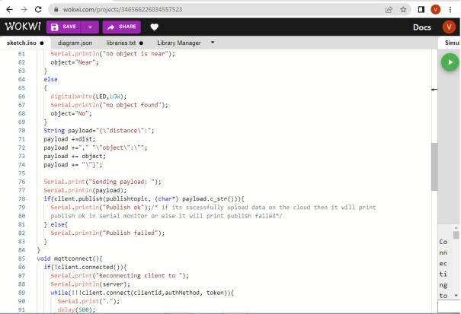

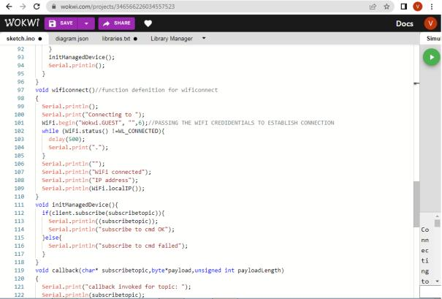

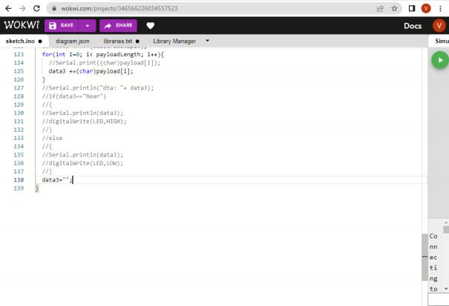

O UT P UT:

DATA IS S E NT TO I B M C LO U D W H E N NO O BJ ECT IS D ET ECT E D

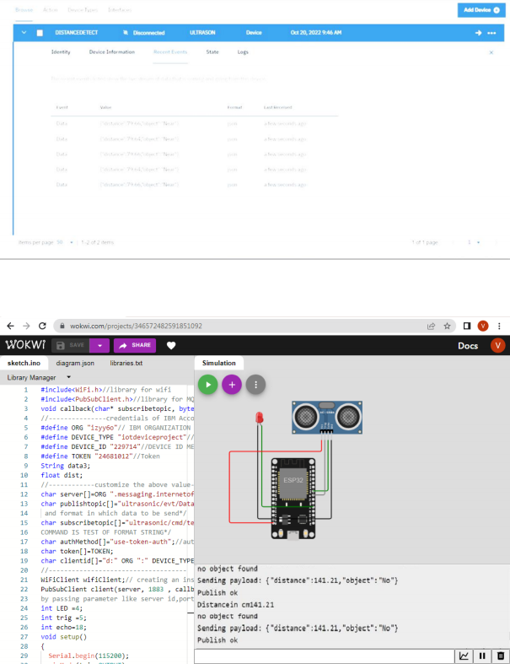

W he n no o bject is detected

Data is se nt to i b m c lo ud w he n o bject is detected

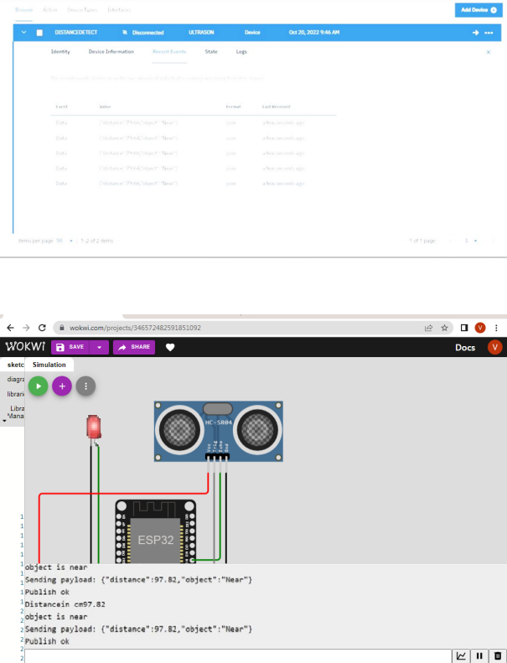W he n o bject is detected i n u lt raso nic detecto r